Manila Water Company
technical specification – FORM
DID_M2C_130
Return Letter



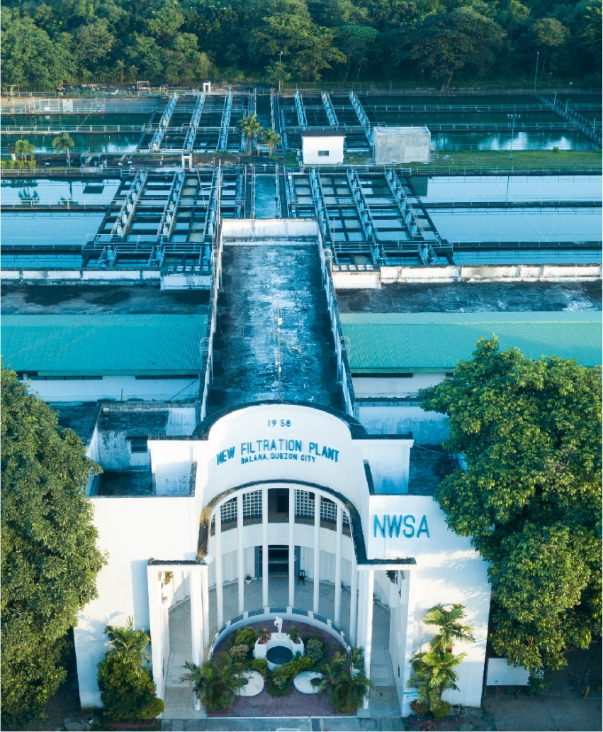
Contents
1 Document Organization 4
1.1 Document Log 4
1.2 Integration, Document Reference 4
2 Program Attributes 5
2.1 Authorization Requirements 5
2.1.1 Definition 5
2.1.2 Defined Fields 5
2.1.3 Procedure 5
2.2 Technical Flow Diagram 5
2.3 Form adjustment steps [New output management only] 5
2.4 Output Control Configuration 6
2.5 Form Processing Logic 6
3 Assumptions in Technical Design 6
4 Open Issues in Technical Design 6
5 Unit Test Results 6
6 Related Documentation 7

Document Organization
This section provides details about this document, previous version(s) of this document and the document(s) referred.

Document Log
The following table mentions the version changes and the processer(s):
Version | Status | Date | Version Created by (Name/E-Mail/Company) | Role | Comments
 | Ready for Review | May 16, 2025 | Ritika Jain | Author
 | Choose an item. | Click here to enter a date. |  | Choose an item.

Integration, Document Reference

S. No. | Referred Document Name | Referred Document Version | Referred Document URL (Optional)

Program Attributes
Form title
Form Name | ZAF_M2C_FICA_RETURN_LETTER
Package | ZS4_MWC_M2C_FICA
Form Interface | ZZIF_M2C_FICA_RETURN_LETTER

Authorization Requirements

Definition
Customers paid their Bills at Cash desk or at payment facility by cheque. Cheque deposited in the bank and cheque dishonor. MWC send return latter to customers about the return’s latter. MWC print the return latter and send to the customer.

Defined Fields
N/A

Procedure
This form can be printed after posting the return lots. MWC executives will execute the T code FPCOPARA and it will print the return later in the local printer.

Technical Flow Diagram

Form adjustment steps [New output management only]
N/A

Output Control Configuration
N/A

Form Processing Logic
1. CAN (Contract Account Number)
- Read table DFKKCOH where ENTID2 = 'OBEL'.
- Get the value of DATA2, which represents the document number (OPBEL).
- Read table DFKKOP using OPBEL = DATA2.
- Get the value of VKONT from DFKKOP → this is the Contract Account Number (CAN).

2. Account Name
- Read table DFKKCOH where ENTID2 = 'OBEL'.
- Get the value of DATA2 and use it as OPBEL.
- Read table DFKKOP using OPBEL = DATA2.
- Get the value of GPART from DFKKOP.
- Read table BUT000 using PARTNER = GPART.
- Get values of NAME_ORG1, NAME_ORG2, NAME_ORG3 → concatenate for full Account Name.

3. Address
- Follow steps from point 2 to get GPART.
- Read table BUT020 using PARTNER = GPART to get ADDRNUMBER.
- Read address tables (ADRC, ADR6, etc.) using ADDRNUMBER.
- Get fields like STREET, CITY1, POST_CODE1, REGION, COUNTRY for full address.

4. Official Receipt Number & Document Posting Date
- Read table DFKKCOH where ENTID2 = 'OBEL'.
- Get DATA2 and use it as EXKEY in table DFKKEXTDOC.
- Read table DFKKEXTDOC using EXKEY = DATA2 and get EXBEL.
- Read table DFKKKO using OPBEL = EXBEL.
- Get POST_DATE from DFKKKO → this is the document posting date.

5. Check Number and Date
- Read table DFKKCOH where ENTID2 = 'OBEL'.
- Get DATA2 and use it as OPBEL in table DFKKZP.
- Read table DFKKZP using OPBEL = DATA2.
- Get CHCKN for Check Number.
- Get TXTVW for Check Date (note: may be a text/date field depending on usage).

6. Reason
- Read table DFKKCOH where ENTID2 = 'OBEL'.
- Get DATA2 and use it as OPBEL in table DFKKRP.
- Read table DFKKRP using OPBEL = DATA2 and get RLGRD.
- Read table TFK045A using RLGRD.
- Get RTEXT from TFK045A → this is the Reason Description.

Assumptions in Technical Design
N/A

Open Issues in Technical Design
N/A

Unit Test Results

Scenario # | Input Selection Criteria | Expected Result | Actual Test Pass/Fail
1 | Customer Paid at Cash desk and Cheque dishonored | MWC agent post return lot and print the return letter. | Pass
2 | Customer Paid at payment facility and Cheque dishonored | MWC agent post return lot and print the return letter through FPCOPARA. | Pass

Related Documentation

Template Version

Version | Status | Date | Version Created by (Name/E-Mail/Company) | Role | Comments
1.0 | Final | February 11, 2019 | Abhishek Nayak | Author
 | Choose an item. | Click here to enter a date. |  | Choose an item.

